Hut Layout Concept

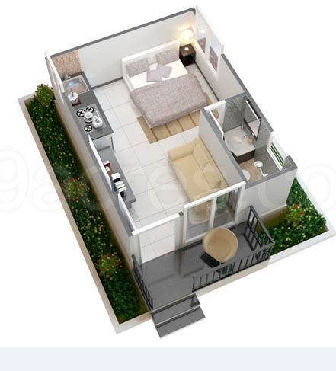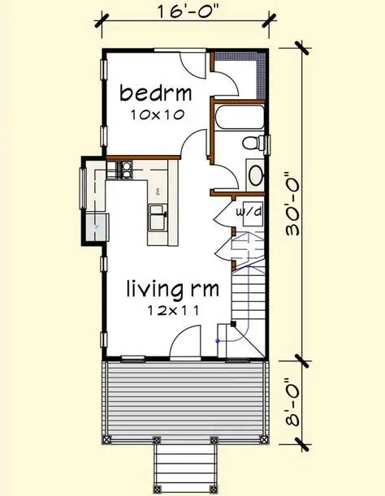
- Entry veranda (25 sq ft): Wide wooden deck with cane chairs and potted greenery — rural charm meets resort elegance.
- Bedroom (80 sq ft): Queen bed, side tables, and a large window with sheer curtains for natural light.
- Living area (70 sq ft): Sofa, coffee table, and wall-mounted TV; open to the bedroom via a sliding partition for flexibility.
- Kitchenette (45 sq ft): Compact counter with sink, induction stove, and mini-fridge; tiled backsplash adds urban flair.
- Bathroom (30 sq ft): Corner shower, vanity, and toilet with modern fixtures.

🌿 Design Blend
- Rural elements: Wooden textures, earthy tones, and natural ventilation.
- Urban elements: Sleek lighting, glass partitions, and efficient space use.
- Color palette: Warm beige, soft white, and matte black accents.
Interior
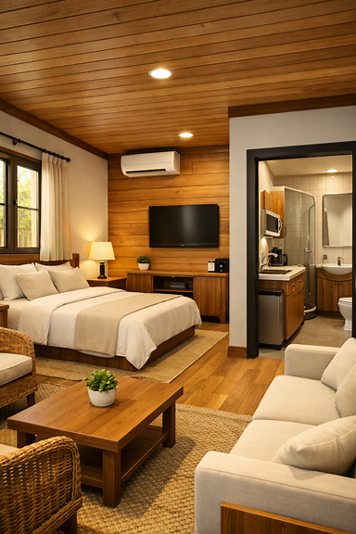

Here’s the interior walkthrough view of your 250 sq ft resort cottage — a warm, inviting space that perfectly balances rural textures with urban comfort.

🏡 Interior Highlights
- Living area: Cozy sofa and wicker chair around a wooden coffee table, accented by a jute rug and soft lighting.
- Bedroom: Queen bed with neutral linens, bedside lamp, and a large window with sheer curtains overlooking greenery.
- Kitchenette: Sleek counter with sink, cooktop, microwave, and mini-fridge — compact yet functional.
- Bathroom: Frosted glass door, curved shower, vanity, and toilet — modern and efficient.

🌿 Design Blend
- Rural charm: Wooden ceiling, woven textures, and natural light.
- Urban comfort: Subtle lighting, tiled backsplash, and clean lines.
- Color palette: Warm beige, white, and wood tones with green accents.

Exterior
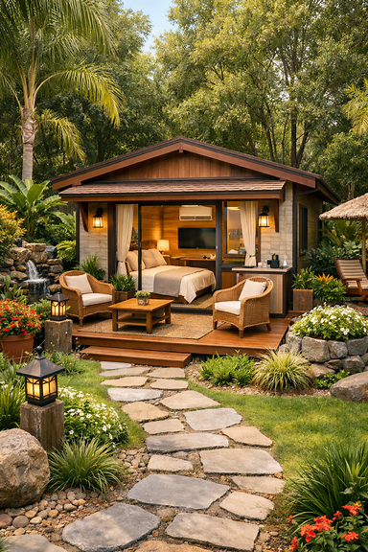
Here’s your resort cottage with full landscaping — a serene tropical setting that enhances the 250 sq ft design beautifully.

🌿 Landscape Highlights
- Stone pathway: Flagstone trail leading to the porch, bordered by ornamental grasses and flowering plants.
- Garden lighting: Lantern-style fixtures on rustic posts for warm evening ambiance.
- Tropical foliage: Palms, ferns, and red-orange blooms surrounding the cottage for lush privacy.
- Water feature: A small stone waterfall tucked among ferns adds soothing sound and visual appeal.
- Outdoor seating: Thatched umbrella with lounge chairs for relaxation under shade.
The blend of natural textures, vibrant greenery, and warm wood tones creates a tranquil resort vibe — perfect for guests seeking peace and connection with nature.

